Recursion is a programming technique where a method calls itself to solve smaller sub problems of the original problem. It’s useful for problems that can be broken into repetitive substructures, such as computing factorial, Fibonacci numbers, or predicting compound values over time.

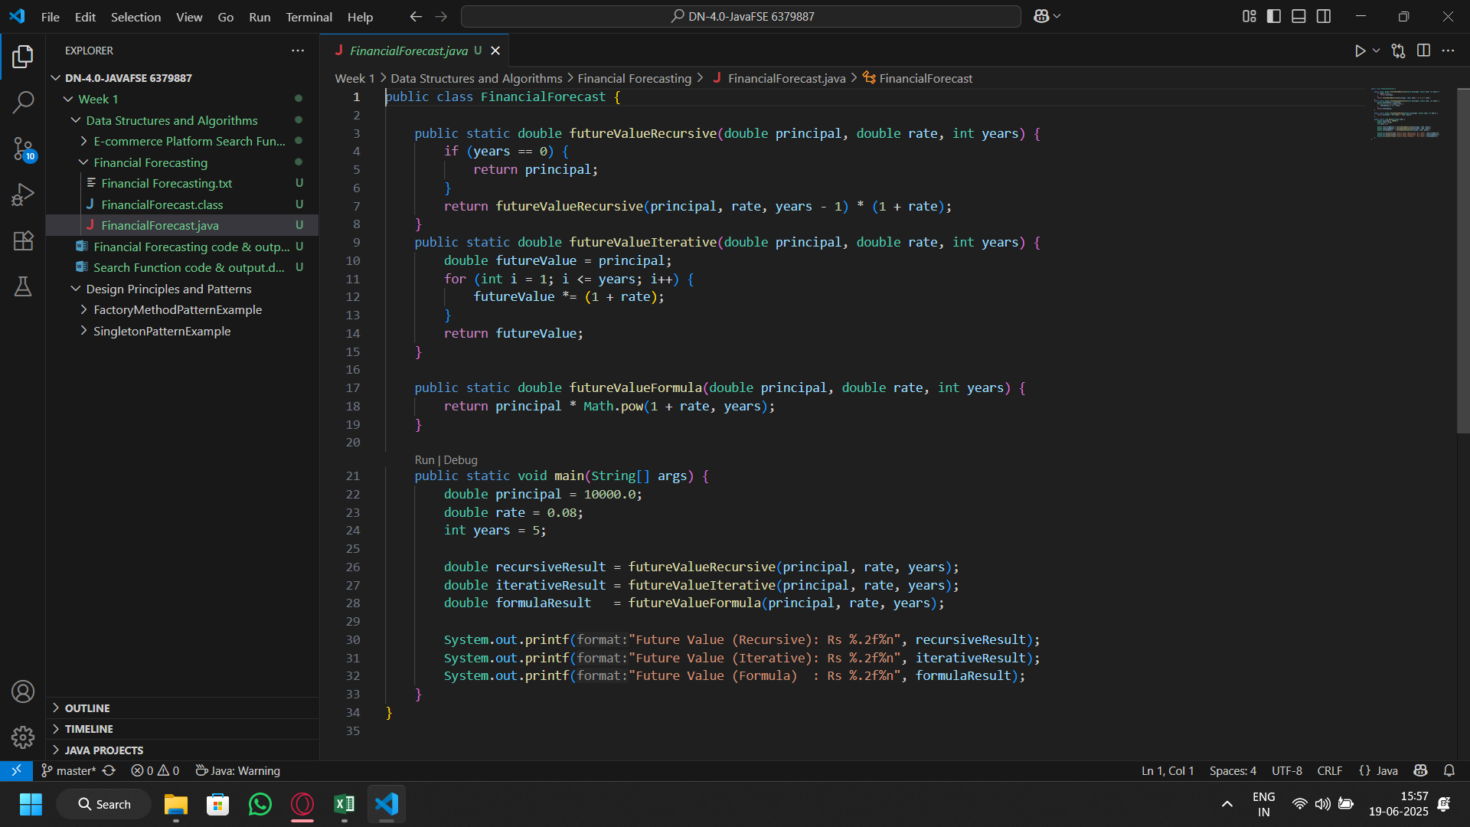
Code:

Output:
